caXchange Hub

caXchange – ScenPro, Inc.
Ekagra
Design Document

DOCUMENT CHANGE HISTORY
Version Number | Date | Contributor | Description
1.0 | 11/27/07 | Michael Holck | Initial Draft that describes the design of the elements included in the Elaboration phase
1.1 | 1/7/08 | Michael Holck | Added information describing the elaboration phase and construction phase I components
1.2 | 1/8/08 | Kalpesh S. Patel | Added caXchange Hub design information.
1.3 | 1/10/08 | Kalpesh S. Patel | Added Logging and Auditing design information.
1.4 | 1/17/08 | David Dorman | Update information presentation
1.5 | 2/05/08 | Amit Srivastava | Updated some information and diagrams
1.6 | 07/03/08 | Harsh Marwaha | Added externalized routing design.


Updated Feb 05, 2008

TABLE OF CONTENTS
1.0 Background/Summary 1
2.0 Introduction 2
2.1 Overview 2
2.2 Scope 2
2.2.1 caXchange Hub 2
2.2.2 Common Logging Module Integration 2
2.3 Related Documentation 3
3.0 caXchange Design 4
3.1 caXchange Hub 4
3.1.1 Component View 4
3.1.2 Logical Design 5
3.1.2.1 caXchange Grid Service 5
3.1.2.2 caXchangeResponse Listener 5
3.1.2.3 caXchange Service Assembly 6
3.1.2.4 caXchange Service Assembly- Externally Configurable Routing 8
3.1.2.4.1 caxchange.properties: 8
3.1.2.4.2 Bean service unit configuration: 8
3.1.2.4.3 EIP Routing configuration: 9
3.1.3 Sequence Diagrams 10
3.1.3.1 Successful Flow Sequence Diagram 10
3.1.3.2 Rollback Flow Sequence Diagram 10
3.1.4 Data 11
3.1.5 Deployment 12
3.1.6 Test Cases and Scenarios 13
3.2 Common Logging Module Integration 13
3.2.1 Requirements 13
3.2.1.1 Trace Message Flow Through caXchange 13
3.2.1.2 Filter Messages to log by User 13
3.2.2 Component View 13
3.2.3 Local Design 14
3.2.4 Sequence Diagram 15
3.2.5 Data 16
3.2.6 Deployment 17
3.2.6.1 Sample servicemix.xml configuration 17
3.2.7 Test Cases and Scenarios 18
4.0 Appendix 18
4.1 caxchange.properties 18
4.2 caXchange Beans Service Unit Configuration 19
4.2.1 beans.xml 20
4.2.2 endpoints.xml: 20
4.3 caXchange EIP Routing Configuration 21
5.0 Glossary 22
LIST OF FIGURES
Figure 1 caXchange Component View 4
Figure 2 caXchange Response Listener 6
Figure 3 caXchange Successful Flow Sequence Diagram 10
Figure 4 caXchange Rollback Interaction Sequence Diagram 11
Figure 5 Database Table for caXchange Messages 12
Figure 6 caXchange Deployment Model 12
Figure 7 Component Model 13
Figure 8 CLM Integration Class Model 15
Figure 9 Logging and Auditing Successful Scenario Sequence Flow 16
Figure 10 Common Logging Module Integration Deployment Model 17
LIST OF TABLES
Table 1 caXchange Hub Related Documents 3
Table 2 caXchange Grid Service Operations 5
Table 3 caXchange Service Assembly Components 6
Table 4 ExchangeListener Interface Operations 14

Background/Summary
The overall goal of this project is to build a hub system that can be adapted and extended to multiple data formats and whose value and usability can be applied in one or more cancer centers. As the caBIG program is the primary sponsor, all work performed for this project must be done in compliance with the caBIG principles of open source, open development, open access, and federation. Software that is used and/or developed in the context of this project must be caBIG™ compatible at the silver level and be made available to the community through resources provided by the General Contractor.
(https://cabig.nci.nih.gov/guidelines_documentation/caBIGCompatGuideRev2_final.pdf

Introduction

Overview
This Design document captures the software design for only the software components of the caXchange version 1.1. The overall goal of this project is to build a hub system that can adapt and extend data to multiple formats and whose value and usability can be pilot tested in one or more cancer centers. This includes a cancer center hub client to submit laboratory data to CTODS as well as a Lab Viewer application to view this data. The Lab Viewer will be interoperable with other CCTS applications.

Scope
The scope of this document is limited to only the design of the caXchange components detailed in the following sections.

caXchange Hub
The caXchange Hub is the software component that is primarily responsible for receiving input from various external systems, routing the input to various services that are hosted on the hub, and eventually routing the output of those services to external systems. caXchange is implemented using Servicemix 3.1.2 enterprise service bus (ESB) for routing and exposing that functionality using a service deployed on caGrid. caXchange is deployed as a service assembly on Servicemix 3.1.2. caXchange grid service acts as a proxy to the service assembly.

Common Logging Module Integration
The Common Logging Module (CLM) provides the audit and logging services under caCORE set of tools. It includes a set of tools such as the log-locator web application. Integrating CLM with caXchange for logging enables the use of these tools for caXchange logs.

Related Documentation
For additional information on caXchange Hub, version 1.1, please refer to following documents:
Table 1 caXchange Hub Related Documents
Document | Version | Location
caXchange Use Case Specification and Realization Document | 1.0 | https://gforge.nci.nih.gov/plugins/scmcvs/cvsweb.php/caxchange/Deliverables/Use%20Case%20Specification%20and%20Realization%20Documents%20(Task%202.1).rtf?cvsroot=caxchange
caXchange Software Requirements Specification Document | 1.0 | https://gforge.nci.nih.gov/plugins/scmcvs/cvsweb.php/caxchange/Deliverables/Software%20Requirement%20Specifications%20(Task%202.2).doc?cvsroot=caxchange
caCORE 3.2_Tech_Guide (Chapter 10: Common Logging Module)
CSM – User Provisioning Tool User Guide |  | (ftp://ftp1.nci.nih.gov/pub/cacore/CSM/UPT_User_Guide.pdf)
Servicemix Documentation |  | http://servicemix.apache.org/documentation.html
Java Business Integration Specification |  | http://jcp.org/en/jsr/detail?id=208
caXchange Interface Specification |  | https://gforge.nci.nih.gov/plugins/scmcvs/cvsweb.php/caxchange/Documentation/Interface/caXchange_Interface_Specification.doc?cvsroot=caxchange
caXchange Design Diagram |  | https://gforge.nci.nih.gov/plugins/scmcvs/cvsweb.php/caxchange/Documentation/Design/reliable-messaging-diagram.odg?cvsroot=caxchange
caXchange Administration Guide |  | http://gforge.nci.nih.gov/plugins/scmcvs/cvsweb.php/caxchange/Documentation/admin/caXchange%20Administration%20Guide.doc?cvsroot=caxchange

caXchange Design
The design of the caXchange components are detailed in the following sections.

caXchange Hub

Component View
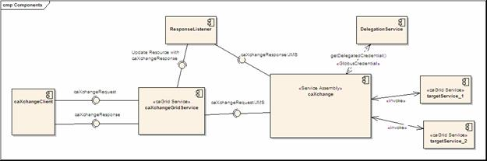
Figure 1 caXchange Component View
Figure 1 shows the high level components in caXchange. Please refer to the caXchange design diagram for the components within the caXchange service assembly.
- A caXchange client sends a caXchangeRequest message to caXchangeGridService.
- caXchangeGridService is a caGrid service which acts as a proxy for the caXchange service assembly deployed on Servicemix JBI (Java Business Integration) Container.
- caXchangeGridService creates a WS-Resourceframework Resource associated with the caXchangeRequest. This caXchangeRequest is then forwarded to the caXchange service assembly for processing. This is done by pushing caXchangeRequest message to the jms inbound component of caXchange service assembly.
- caXchange service assembly then invokes the DelegationService for the authorization credentials before routing the request message based on the message type. Please refer to the caXchange detailed design diagram for routing details.
- Outbound components then invoke the target services.
- Responses from the target services are then composed into a caXchangeResponse message.
- caXchangeResponse is then pushed to the jms outbound component.
- The response listener then picks up the caXchangeResponse and updates the WS-Resourceframework resource created in step 3.
- The caXchangeResponse is then available to the client.

Logical Design

caXchange Grid Service
The caXchange grid service acts as a proxy for caXchange. It forwards incoming requests to caXchange for processing. To keep track of a request it creates a WS-Resource framework resource. The grid service then returns an EndPointReference to the client. The client uses this end point reference to invoke the getResponse operation. The grid service also creates a response listener, which listens for caXchangeResponse and updates the resource. Please see the caXchange Interface Specification document for details of the operations it exposes.
Table 2 caXchange Grid Service Operations
Method | Notes | Parameters | Return
ProcessRequestAsynchronously | Process a caXchangeRequest | CaXchangeRequest | CaXchangeContextReference
getResponse | Gets the caXchangeResponse if it is ready, otherwise throws an Exception | None | caXchangeResponse

caXchangeResponse Listener
The caXchangeResponse listener lives with the caXchange Grid service. It listens for the response on the jms queue associated with the response outbound component of the caXchange service assembly. Once a response is received from the queue, the resource associated with the corresponding request is updated. The client can then use the getResponse method to get the caXchangeResponse.

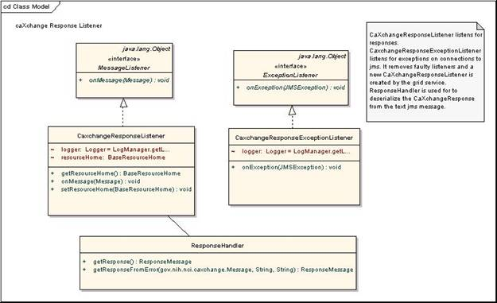
Figure 2 caXchange Response Listener

caXchange Service Assembly

The caXchange service assembly is deployed on the Servicemix JBI container. The caXchange design diagram gives the detailed design of the caXchange service assembly.
Table 3 describes caXchange service assembly components. Numbers in the component column refer to the number in the caXchange design diagram given to an exchange going into that component.
Table 3 caXchange Service Assembly Components
Component | Type | Purpose
1. InboundComponent | JMS | Receive inbound caXchangeRequest messages.
3. Invoke Delegation Service | Bean/EIP (Enterprise Integration Patterns) | This includes two components, a pipeline, which invokes a bean component that calls delegation service for authentication and authorization.
3. 3/4.3 Response Generator | Bean | Generates an error response
4. Save Message | Bean/EIP | This includes two components, a pipeline, which invokes a bean component that saves the message to a database. The saved message is used to contruct a response and/or sends a rollback.
5. Content Based Router | EIP | Routes the message based on the message type to a particular static recipient list.
6. Static Recipient List | EIP Customized | Sends the message to multiple recipients for invoking target services. This is customized to add a message property for number of recipients. This is used to aggregate responses
7. Content Based Router | EIP | Routes message based on operation. If the operation is process the message is routed to a pipeline to invoke the service and get a response as an in-out message exchange. If the operation is rollback the message is send without expecting a response as an in-only message exchange.
8.1. Pipeline | EIP | Pipeline to invoke target service as an in-out message exchange.
8.2. Outbound Component | Bean | Outbound component that invokes the target Grid Service.
8.4. Aggregator | EIP Customized | Aggregator component aggregates responses from multiple target services. This is customized to work with the customized static recipient list in #6 above.
9. Aggregator Listener | Bean | Aggregated responses from the aggregator are forwarded to this component, which does two things. It looks at the response and the message type to verify if a rollback is required. If required a message with the rollback is sent to the content based router #5 after authentication and authorization by #3.It creates a caXchangeResponse and sends it to the jms outbound binding component.
10. ResponseComponent | JMS | Outbound caXchangeResponse are pushed to this component.

caXchange Service Assembly- Externally Configurable Routing

caXchange service assembly deployment will include externally configurable routing. This will be done by providing administrators externally available configuration files. These files will provide caXchange administrators an ability to configure routing, add and alter target grid services, modify caXchange service assembly properties. caXchange administration guide provides additional details for administrators to configure routing to new target grid endpoints. These files include the following:

caxchange.properties:
This file includes a number of caXchange properties, such as JMS address, target service URLs and so forth. Details of the caxchange.properties file are provided in the appendix.

Bean service unit configuration:
This will include two configuration files beans.xml, and endpoints.xml. Beans.xml defines the beans needed for the caXchange service assembly. The endpoints.xml file includes the xml for defining the bean end points for the target Grid Services. These files will be imported into the xbean configuration file for the caXchange beans service unit. Configuration file details are provided in the appendix.

caXchange service assembly will provide a generic bean component that can be configured for routing to additional target grid services. This bean component can be configured with the following attributes:
Attribute Name | Attribute Description | Required
serviceUrl | The URL for the target grid service. | Yes
gridClientClassName | The class name for the caGrid client for invoking the target grid service. | Yes
operationName | The operation to be invoked on the target grid service. | Yes
requestPayloadClassName | The request payload class that is sent as a parameter to the target grid service. This is required to us the grid client to invoke the target grid service. | Yes
returnTypeNameSpace and returnTypeElement | The name space and element name for the response payload respectively. This is required to serialize the response object to return to the caXchange client. | No

caXchange administrators can configure additional beans and endpoints to provide routing to new target grid services. caXchange installation guide provides additional details for administrators to configure custom target grid end points.

EIP Routing configuration:
This file includes the xml defining the EIP routing components. caXchange administrators can modify these definitions to alter routing of messages within caXchange. Details of the configuration files are provided in the appendix.

Verify routing is another feature within caXchange externalizes routing. This tool will verify any changes that administrators do to the external configuration files. This tool will load the xml configuration files for the caXchange EIP service unit and the bean service unit. It will then recursively verify that the target services used for the route of each message type are defined in the EIP configuration or the bean configuration files. If a target service is not defined in the configuration this tool will display the name of the service and the component it is referred in.

Sequence Diagrams

Successful Flow Sequence Diagram
The sequence for a successful flow through caXchange is depicted in Figure 3. Detailed flow through the caXchange service assembly is depicted in the caXchange design diagram.
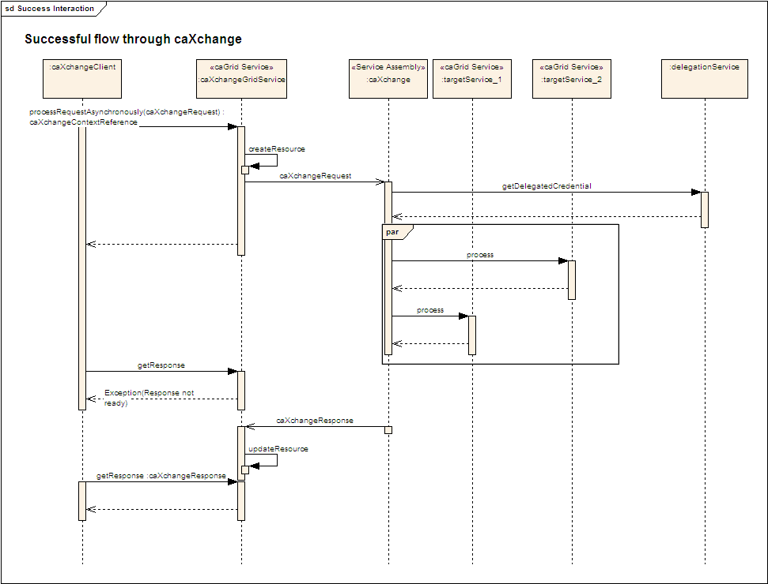
Figure 3 caXchange Successful Flow Sequence Diagram

Rollback Flow Sequence Diagram
The sequence for a rollback interaction with caXchange is depicted in Figure 4. Detailed interaction within the caXchange service assembly is depicted in the caXchange design diagram.
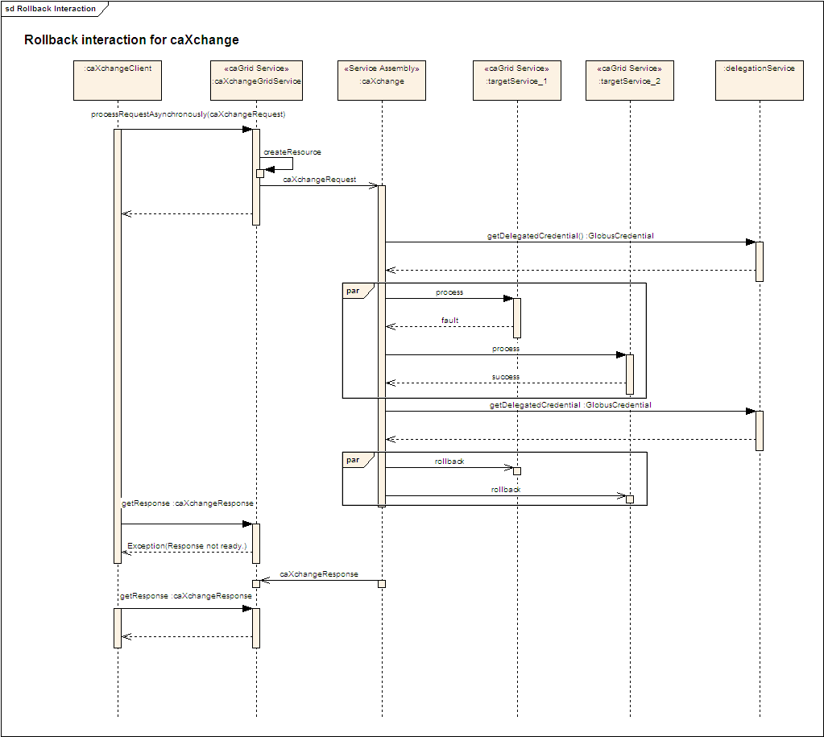
Figure 4 caXchange Rollback Interaction Sequence Diagram

Data
A database schema has been created to facilitate saving the inbound caXchange request message for sending rollbacks and for creating aggregated/error responses. The message is stored in the database table primarily for two reasons. To ensure that the message under processing within caXchange is not lost due to ESB or caXchange node or component failure, the message in its entirety is stored in the database table. Secondly as the message is processed within ESB framework, its metadata (such as grid credentials) are consumed and only the message payload remains in the memory. In case of the rollback the entire message, including metadata, is needed. In such an event the stored message is used to issue the rollback message.

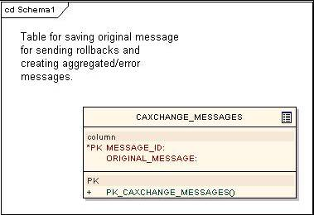
Figure 5 Database Table for caXchange Messages

Deployment
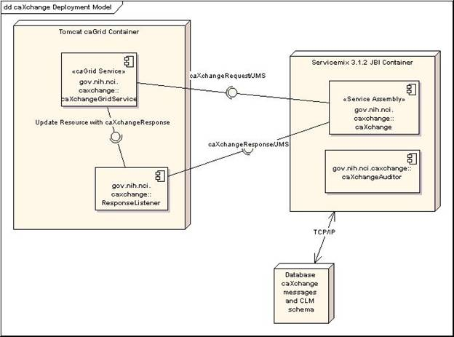
Figure 6 caXchange Deployment Model

Test Cases and Scenarios
Please refer to the caXchange Testing Approach Document for test cases.

Common Logging Module Integration

Requirements

Trace Message Flow Through caXchange
The user should be able to see the how a message was processed through caXchange.

Filter Messages to log by User
The user should have the ability to filter the messages they want to log.

Component View
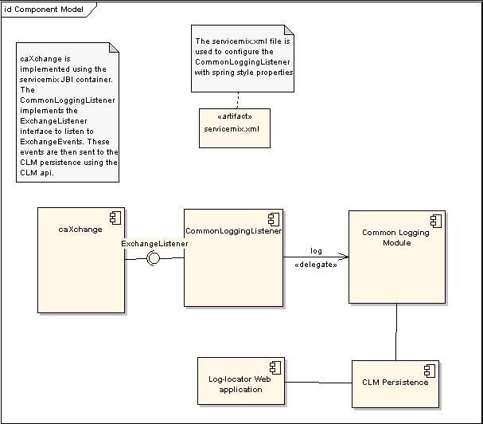
Figure 7 Component Model
- CommonLoggingListener registers with the caXchange Servicemix JBI Container to listen for all ExchangeEvents
- Servicemix JBI Container sends ExchangeEvents all registered ExchangeListeners ExchangeEvents.
- CommonLoggingListener logs the exchange events using the Common Logging Module.
- CommonLoggingListener can be configured using servicemix.xml with spring style configuration.

Local Design
The integration between CLM and caXchange has been achieved by implementing the ExchangeListener interface of servicemix. The CommonLoggingListener implements this interface. Additionally it adds properties to enable logging of messages meeting certain criteria. Each method of the ExchangeListener can be disabled using spring configuration in servicemix.xml. Additional String filters can be specified in this file, so that only messages matching those filters are logged.
The ExchangeListener interface has the following operations.
Table 4 ExchangeListener Interface Operations
Method | Notes | Parameters
public void exchangeSent(exchangeEvent), | Exchange listener interface. Receives messages from NMR before an exchange is sent. | ExchangeEvent exchangeEvent
public void exchangeAccpeted(exchangeEvent), | Exchange listener interface. Receives messages from NMR after an exchange is accepted. | ExchangeEvent exchangeEvent

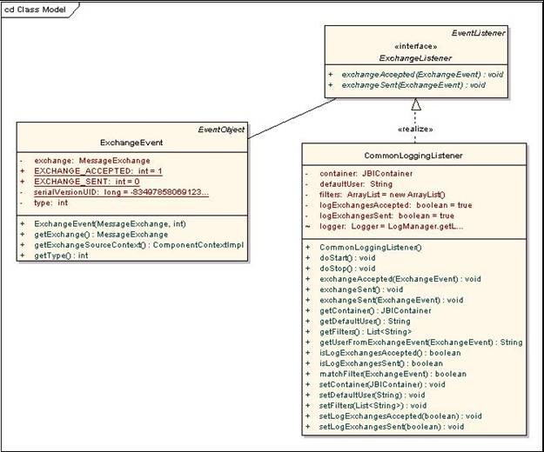
Figure 8 CLM Integration Class Model

Sequence Diagram
The sequence flow of a Successful Scenario is depicted in the following figure.

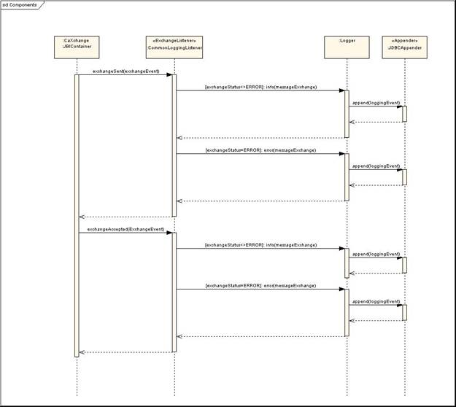
Figure 9 Logging and Auditing Successful Scenario Sequence Flow

Data
A separate CLM database has been created to facilitate logging and auditing for caXchange. Please refer to CLM LLT deployment Guide for more details about the schema.

Deployment
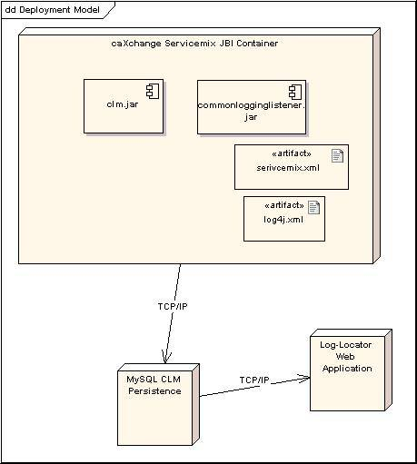
Figure 10 Common Logging Module Integration Deployment Model

Sample servicemix.xml configuration
<bean id="CLMLogger" class="gov.nih.nci.caxchange.servicemix.jbi.audit.CommonLoggingListener" init-method="doStart" >
<property name="container" ref="jbi" />
<property name="logExchangesSent" value="true" />
<property name="logExchangesAccepted" value="false" />
<property name="filters">
<list>
<value>Match</value>
</list>
</property>
</bean>

Test Cases and Scenarios
Please refer to the caXchangeTesting Approach Document for test cases.

Appendix

caxchange.properties

Property Name | Description
inbound.jms.brokerURL | The URL of the JMS provider for the inbound JMS queue. This queue receives the inbound requests from the caXchange grid service.
outbound.jms.brokerURL | The URL of the JMS provider for the outbound JMS queue, This queue makes the outbound responses available to the caXchange grid service.
caxchangedb.driverClass | Database configuration for caXchange, The JDBC driver class name.
caxchangedb.url | Database configuration for caXchange. The JDBC URL.
caxchangedb.username | Database configuration for caXchange.
caxchangedb.password | Database configuration for caXchange
ctom.registration.url | URL for the CTOM register consumer service. Message type REGISTER_SUBJECT are routed to this service.
ctom.registrationRollback.url | URL for the CTOM rollback register consumer service. Message type REGISTER_SUBJECT an operation ROLLBACK are routed to this service.
ctom.study.url | URL for the CTOM study consumer service. Message type STUDY_CREATION are routed to this service.
ctom.studyRollback.url | URL for the rollback of the CTOM study consumer service. Message type STUDY_CREATION, and operation ROLLBACK are routed to this service.
ctom.labLoader.url | URL for the CTOM lab loader service. Message type CT_LAB_DATA are routed to this service.
psc.registration.url | URL for the PSC register consumer service. Message type REGISTER_SUBJECT are routed to this service.
psc.registrationRollback.url | URL for the PSC register consumer service. Message type REGISTER_SUBJECT and operation ROLLBACK are routed to this service.
psc.study.url | URL for the PSC study consumer service. Message type STUDY_CREATION are routed to this service.
psc.studyRollback.url | URL for the PSC study consumer service. Message type STUDY_CREATION and operation ROLLBACK are routed to this service.
psc.adverseEvent.url | URL for the PSC schedule modification service. Message type SCHEDULE_MODIFICATION are routed to this service.
caaers.registration.url | URL for the caAERS register consumer service. Message type REGISTER_SUBJECT are routed to this service.
caaers.registrationRollback.url | URL for the caAERS register consumer service. Message type REGISTER_SUBJECT and operation ROLLBACK are routed to this service.
caaers.study.url | URL for the caAERS study consumer service. Message type STUDY_CREATION are routed to this service.
caaers.studyRollback.url | URL for the caAERS study consumer service. Message type STUDY_CREATION and operation ROLLBACK are routed to this service.
delegation.certificateFilePath | path to the host certificate.
delegation.keyFilePath | path to the host key.
c3d.registration.url | URL for the C3D register consumer service. Message type REGISTER_SUBJECT are routed to this service.
loadLab.url | URL for the CDMS load lab service. Message type LOAD_LAB_TO_CDMS are routed to this service.

caXchange Beans Service Unit Configuration

beans.xml
The beans service unit configuration file beans.xml is a spring like configuration file for defining beans. These beans can then be used to as target end points for routing requests within servicemix.
Following is a sample of the bean configuration for C3D registration service.
<beans xmlns:bean="http://servicemix.apache.org/bean/1.0"
xmlns:caxchange="http://nci.nih.gov/caXchange">
<bean id="c3dRegistration"
class="gov.nih.nci.caXchange.outbound.GridSU">
<property name="strategy">
<ref bean="c3dRegistrationInvocationStrategy" />
</property>
<property name="targetId" value="C3D" />
<property name="targetOperation" value="REGISTER_SUBJECT" />
</bean>
<bean id="c3dRegistrationInvocationStrategy"
class= "gov.nih.nci.caXchange.outbound.operations.RegistrationInvocationStrategy">
<property name="serviceUrl" value="${c3d.registration.url}" />
</bean>
</beans>

endpoints.xml:
The beans service unit file endpoints.xml is also spring like configuration file which defines endpoints for the servicemix beans service unit. These endpoints refer to the beans defined in the beans.xml. Both the beans.xml and endpoints.xml file are imported into the configuration of the caXchange bean service unit. A sample endpoint xml configuration for C3D registration service is given below:
<beans xmlns:bean="http://servicemix.apache.org/bean/1.0"
xmlns:caxchange="http://nci.nih.gov/caXchange">

<bean:endpoint service="caxchange:c3dRegistration" endpoint="c3dRegistrationEndpoint" bean="#c3dRegistration" />
</beans>

caXchange EIP Routing Configuration
The EIP routing configuration consists of a number of files:
File | Description
MessageTypeRouter.xml | This file has the router configuration for routing messages based on message type.
adverseEventRecipients.xml | This file has the configuration for recipients of the SCHEDULE_MODIFICATION message.
labDataRecipients.xml | This file has the configuration for recipients of the CT_LAB_DATA message.
loadLabRecipients.xml | This file has the configuration for recipients of the LOAD_LAB_TO_CDMS message.
registerSubjectRecipients.xml | This file has the configuration for recipients of the REGISTER_SUBJECT message.
studyCreationRecipients.xml | This file has the configuration for recipients of the STUDY_CREATION message.
eip.xml | This file contains the configuration for other EIP components. These include pipeline components for invoking bean end points.

Glossary
Term | Definition
NCICB | National Cancer Institute Center for Bioinformatics
BPEL | Business Process Execution Language
C3PR | Cancer Central Clinical Participant Registry
caAERS | Cancer Adverse Event Reporting System
GUID | A unique ID that the Enterprise Architect product assigns to each object that is created by the tool.
CCHC | Cancer Center Hub Client. The software that is responsible for sending patient laboratory data to the Lab Hub via an interface exposed by the HUB
Endpoint | A destination to which the hub can route data to. An endpoint can represent a service deployed on the hub or an external system to which the hub routes data.
CTMSI | Clinical Trials Management System Interoperability
CCTS | Cancer Clinical Trials Suite
CTODS | Clinical Trials Object Data System

caXchange Interface Specification
caXchange Interface Specification

